**Part A – Integrate-and-Fire Neurons**

**Question 1**

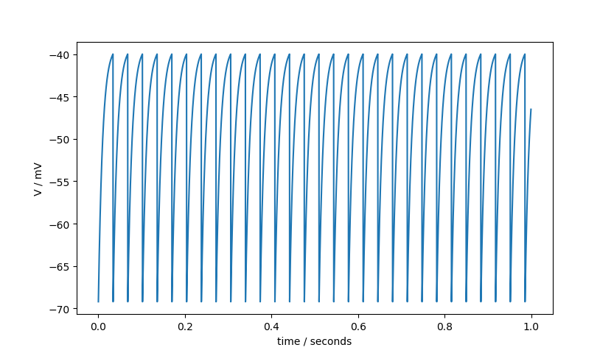

Voltage / mV

**Question 2**

***Es = 0mV :***

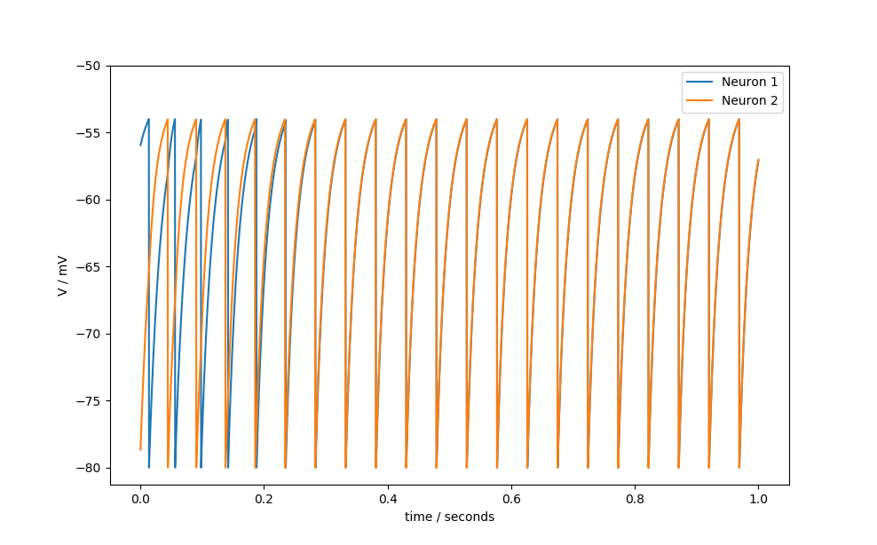

Voltage / mV

***Es = -80mV :***

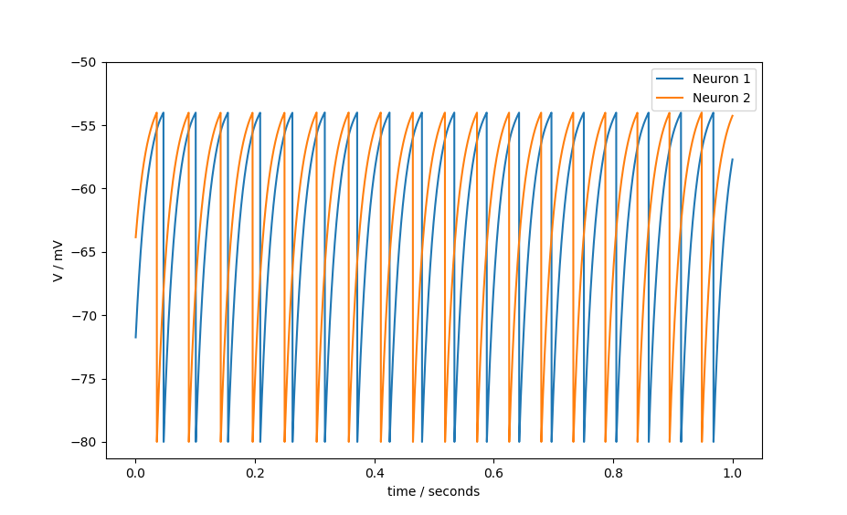

Voltage / mV

For the excitatory synapses with Es = 0mV, we see the firing times of the two neurons converge after about o.2 seconds.

For the inhibitory synapses with Es = -80mV, we see the firing times of the two neurons seeming to separate from each other as time progresses.

An explanation for the behaviour seen could be due to the following:

**Part B – STDP**

**Question 1**

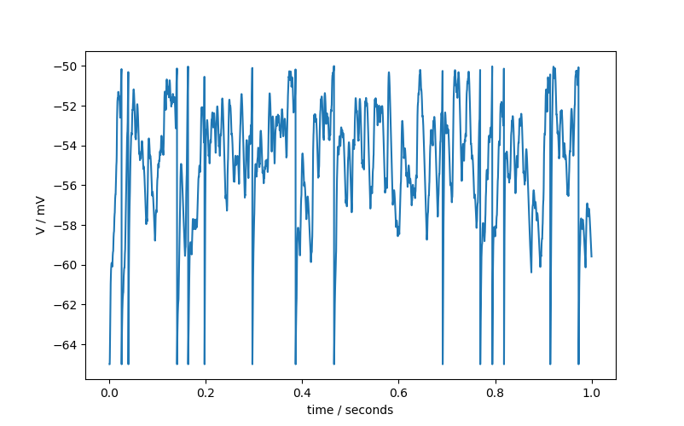

Voltage / mV

**Question 2**

The synaptic strength distribution at the end of simulation time of 300 seconds seems to converge to the minimum value (0 nano-Siemens) and the max value (4 nano-Siemens)

***Steady-State Synaptic Weights After Simulation Run :***

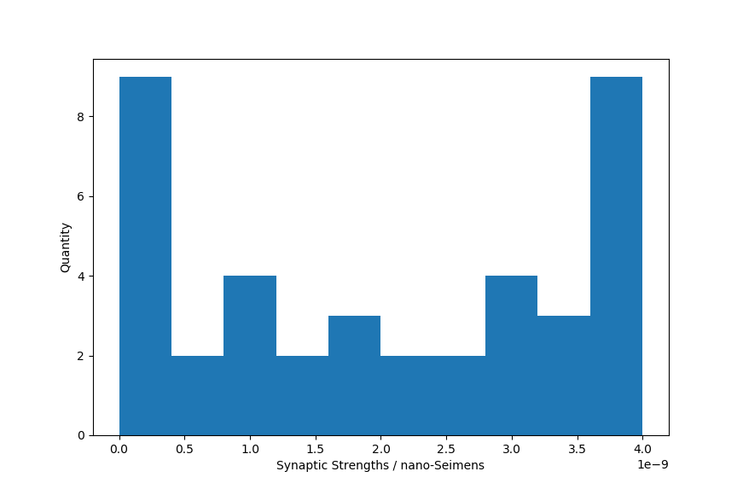

***Average Firing Rate of Postsynaptic Neuron (10 second time bins):***

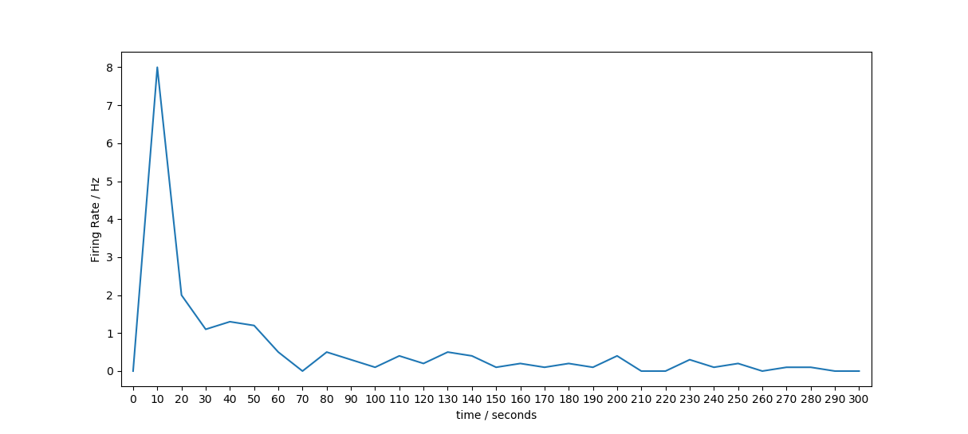

Average Steady state firing rate for STDP ‘on’ (averaged over last 30 seconds) after 5 simulation runs = (0.06666 + 0.16666 + 0.16666 + 0.13333 + 0.033333)/5 = 0.1133Hz

Average Steady state firing rate for STDP ‘off’ (averaged over last 30 seconds) after 5 simulation runs = (0.0 + 0.0 + 0.0 + 0.0 + 0.0)/5 = 0.0Hz

**Question 3**

STDP ‘on’ :

STDP ‘off’ :

***Mean Output Firing Rate STDP ‘on’ :***

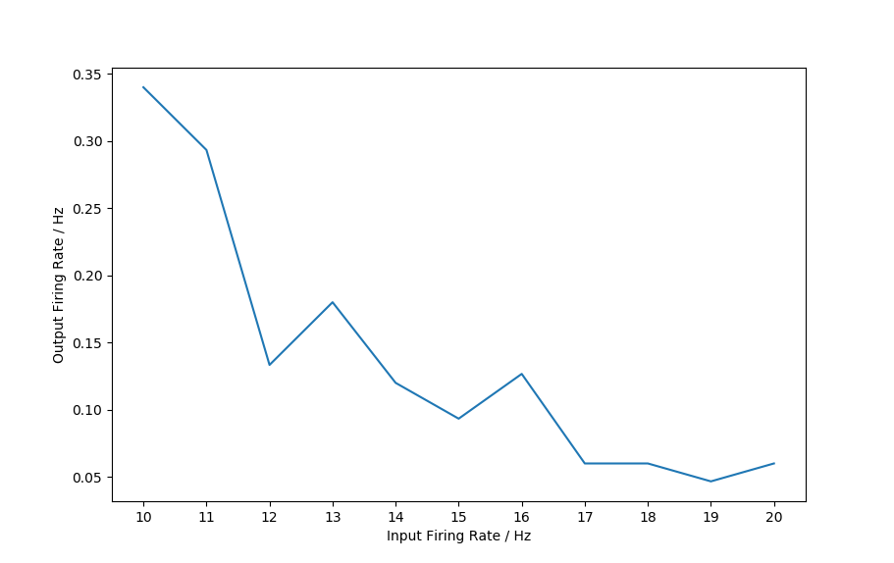

***Mean Output Firing Rate STDP ‘off’ :***

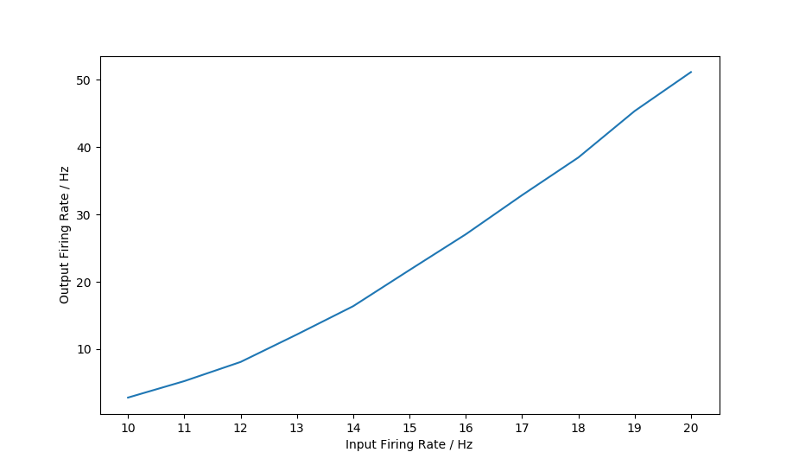

***Steady-State Synaptic Strength Distribution for Firing Rate = 10Hz, STDP ‘on’ :***

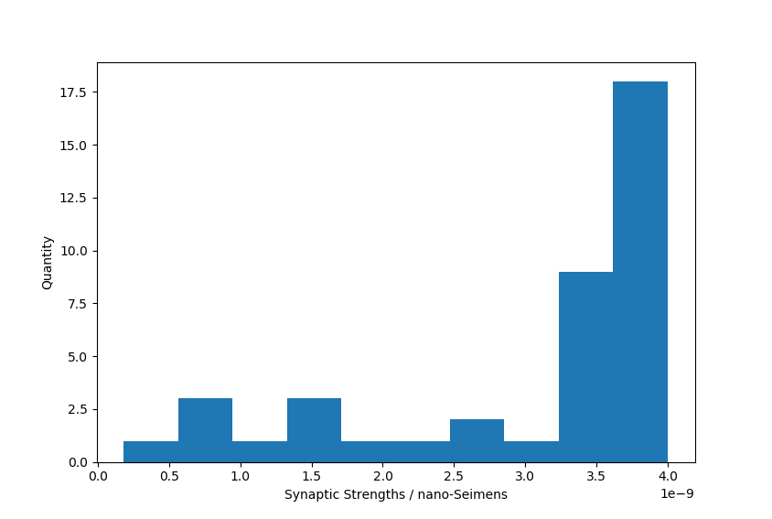

***Steady-State Synaptic Strength Distribution for Firing Rate = 20Hz, STDP ‘on’ :***

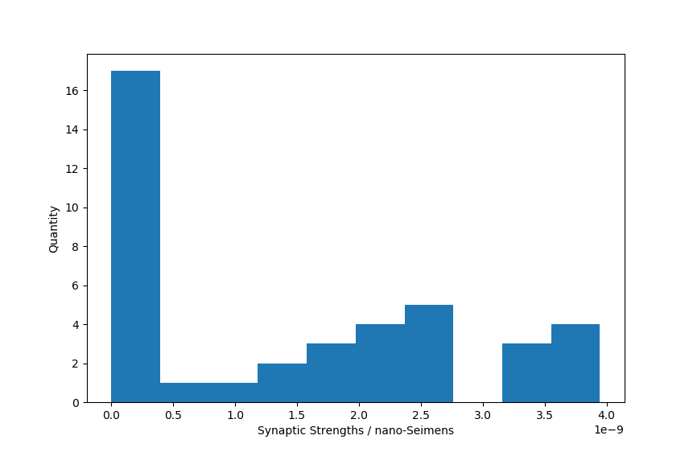

What’s happening? Why does this make sense?

**Question 4**

How does the degree of correlation affect the steady state synaptic weights?

***Mean of Steady-State Synaptic Strengths :***

***Standard Deviation of Steady-State Synaptic Strengths :***

***Steady-State Synaptic Strengths for B = 0Hz :***

***Steady-State Synaptic Strengths for B = 20Hz :***

Give explanation for what you think is happening